Hitman Pro 3.7.12 liefert das nachfolgende Scan-Ergebnis:

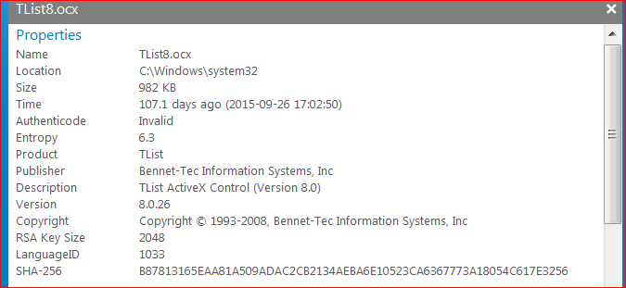

Scoring (22.0):

Program is altered or corrupted since it was code signed by its author. This is typical for malware and pirated software.

The file is located in a folder that contains core operating system files for Windows. This is not typical for most programs and is only common to system tools, drivers and hacking utilities.